**Assignment 1.2 Report – Brandon Dooley (#16327446)**

**Progress:**

This week I created and implemented a *Gateway* class which will be designed to work in conjunction with the *Client* and *Server* class to fulfil the assignment specifications. The *Gateway* class was created similarly to the *Server* class with a constructor, as well as methods such as:

* *main()*
* *start()*
* *onReceipt()*

The constructor is of the form:

**Gateway**(**Terminal** terminal, **String** serverHost, **int** serverPort, **String** clientHost, **int** clientPort, **int** gatewayPort)

It creates a new DatagramSocket object at the definied *gatewayPort* (40000), as well as creating InetSocketAddress’ for both the server and the client. This is done in order for the Gateway to be able to communicate back and forth between both client and server.

When the Gateway receives some form of interrupt the *onReceipt()* method is called upon. The method first performs a comparison operation between the received packet’s port number and the clients port number. This is done to determine whether the packet came from the client or the packet is an ACK from the server.

If the packet has in fact came from the client, the Gateway proceeds to forward the packet on to the server by changing the packets port number to that of the socket at the server (50000). The gateway then continues to wait for a response from the server.

When and if the server receives the packet that was sent from the Gateway it processes this packet and prints the encapsulated data to the terminal as seen below. It then proceeds to send an acknowledgement packet (**ACK**) back to the Gateway to inform both the Gateway, and in turn the client, that the original packet has been received.

When the Gateway receives a packet which has came from the server it processes it accordingly and continues to forward the ACK back to the original client to inform it that the original packet has reached its end destination correctly.

*Screen Grab of Current Working Solution:*

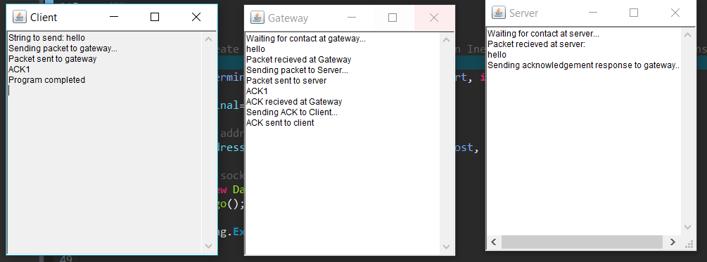

**Problems Encountered:**

* The initial problem I encountered was that I found it pretty confusing finding out where I should start with the assignment. So I began by reading through both of the given classes, Client and Server as well as further reading into some of the objects and methods that were used within these classes.
* Another problem that I encountered was that I had a large amount of difficulty directing the original packet from the Gateway to the Server. I was originally trying to change the address of the packet to that of an InetAddress that I had created for the Server object. However, after a significant amount of trial and error I achieved the desired output by changing the port of the packet to that of the server (50000).
* Originally I had been attempting to use separate *DEFAULT_X_NODE* constants for both Client, Server and Gateway. However, this lead me to a dead end and my program completely stopped working. It was only after a large amount of research and reading through lecture material that I realised all three Objects needed to use the same constant *‘localhost’,* which also thankfully fixed any issues that I was having with sending packets between the objects.

**Plan for Next Week:**

For next week I plan to further implement enclosing sequence number values within the packet buffer e.g within the header. I also hope to implement the setSoTimeout method to allow packets to be re-sent if the correct sequence ACK has not been received within a given time frame.

If this succeeds reasonably well and I have made significant progress I hope to continue on with the second half of the assignment and begin looking at how to implement multiple clients communicating with the Gateway and Server at any given time.